**Reg. no. 20UCA501**

**Ex no:1**

**Create an application to show Toast Message Hello along with the name entered in text box**

**Program:**

**activity_main.xml**

<RelativeLayout xmlns:android="http://schemas.android.com/apk/res/android"

xmlns:tools="http://schemas.android.com/tools"

android:layout_width="match_parent"

android:layout_height="match_parent"

android:paddingBottom="@dimen/activity_vertical_margin"

android:paddingLeft="@dimen/activity_horizontal_margin"

android:paddingRight="@dimen/activity_horizontal_margin"

android:paddingTop="@dimen/activity_vertical_margin"

tools:context=".MainActivity" >

<TextView

android:id="@+id/txtView"

android:layout_width="wrap_content"

android:layout_height="wrap_content"

android:layout_alignParentTop="true"

android:layout_centerHorizontal="true"

android:layout_marginStart="150dp"

android:layout_marginTop="26dp"

android:text="Name" />

<EditText

android:id="@+id/txtName"

android:layout_width="250dp"

android:layout_height="100dp"

android:layout_centerHorizontal="true"

android:layout_marginEnd="8dp"

android:layout_marginStart="8dp"

android:layout_marginTop="50dp"

/>

<Button

android:id="@+id/btnClick"

android:layout_width="wrap_content"

android:layout_height="40dp"

android:layout_below="@+id/txtName"

android:layout_centerHorizontal="true"

android:layout_marginTop="22dp"

android:text="Click Here" />

</RelativeLayout>

**MainActivity.java**

package com.example.toast;

import android.os.Bundle;

import android.app.Activity;

import android.view.View;

import android.widget.Button;

import android.widget.EditText;

import android.widget.TextView;

import android.widget.Toast;

public class MainActivity extends Activity {

private TextView txtView;

private EditText txtName;

private Button btnClick;

@Override

protected void onCreate(Bundle savedInstanceState) {

super.onCreate(savedInstanceState);

setContentView(R.layout.activity_main);

txtName =(EditText)findViewById(R.id.txtName);

btnClick =(Button)findViewById(R.id.btnClick);

btnClick.setOnClickListener(new View.OnClickListener(){

@Override

public void onClick(View view){

StringBuilder strBuilder=new StringBuilder();

strBuilder.append("Hello");

strBuilder.append("\n");

strBuilder.append(txtName.getText().toString());

Toast.makeText(MainActivity.this,strBuilder.toString(),Toast.LENGTH_SHORT).show();

}

});

}

}

**Output**:

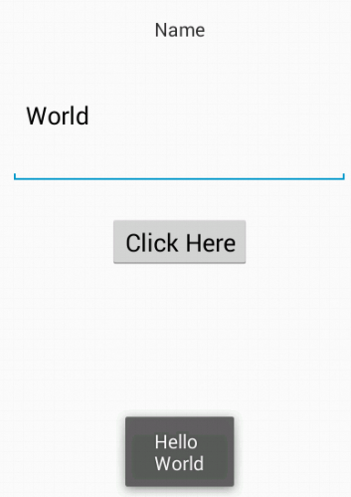

**Ex no:2**

**ACTIVITY LIFE CYCLE**

**Program:**

**MainActivity.java**

package com.example.lifecycle;

import android.os.Bundle;

import android.app.Activity;

import android.util.*;

import android.view.Menu;

import android.widget.*;

public class MainActivity extends Activity {

private static final String TAG_MSG="Activity Life Cycle";

@Override

protected void onCreate(Bundle savedInstanceState) {

super.onCreate(savedInstanceState);

setContentView(R.layout.activity_main);

Log.d(TAG_MSG,"OnCreate");

Toast.makeText(getApplicationContext(),"OnCreate",Toast.LENGTH_SHORT).show();

}

@Override

protected void onStart(){

super.onStart();

setContentView(R.layout.activity_main);

Log.d(TAG_MSG,"OnRestart");

Toast.makeText(getApplicationContext(),"OnRestart",Toast.LENGTH_SHORT).show();

}

@Override

protected void onPause(){

super.onPause();

setContentView(R.layout.activity_main);

Log.d(TAG_MSG,"OnPause");

Toast.makeText(getApplicationContext(),"OnPause",Toast.LENGTH_SHORT).show();

}

@Override

protected void onStop(){

super.onStop();

setContentView(R.layout.activity_main);

Log.d(TAG_MSG,"OnStop");

Toast.makeText(getApplicationContext(),"OnStop",Toast.LENGTH_SHORT).show();

}

@Override

protected void onResume(){

super.onResume();

setContentView(R.layout.activity_main);

Log.d(TAG_MSG,"OnPause");

Toast.makeText(getApplicationContext(),"OnResume",Toast.LENGTH_SHORT).show();

}

@Override

protected void onDestroy(){

super.onDestroy();

setContentView(R.layout.activity_main);

Log.d(TAG_MSG,"OnDestroy");

Toast.makeText(getApplicationContext(),"OnDestroy",Toast.LENGTH_SHORT).show();

}

}

**Output:**

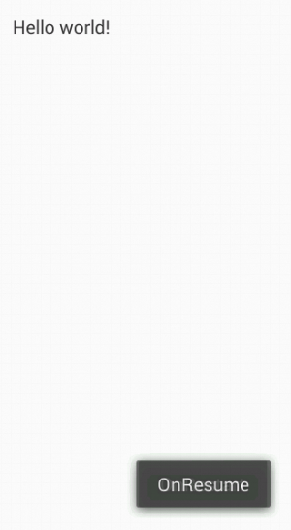

**Ex no:3**

**CHECKBOX**

**Program:**

**MainActivity.java**

package com.example.toastt;

import android.os.Bundle;

import android.app.Activity;

import android.view.Menu;

import android.view.View;

import android.widget.Button;

import android.widget.CheckBox;

import android.widget.TextView;

import android.widget.Toast;

public class MainActivity extends Activity {

private TextView txtview;

private CheckBox ChkBox1,ChkBox2,ChkBox3;

private Button btnClick;

@Override

protected void onCreate(Bundle savedInstanceState) {

super.onCreate(savedInstanceState);

setContentView(R.layout.activity_main);

//txtView=(Text View)findviewById(R.id.txtView);

ChkBox1=(CheckBox)findViewById(R.id.ChkBox1);

ChkBox2=(CheckBox)findViewById(R.id.ChkBox2);

ChkBox3=(CheckBox)findViewById(R.id.ChkBox3);

btnClick=(Button)findViewById(R.id.btnClick);

btnClick.setOnClickListener(new View.OnClickListener() {

@Override

public void onClick(View view) {

// TODO Auto-generated method stub

StringBuilder strBuilder=new StringBuilder();

strBuilder.append("Choosen Answers");

strBuilder.append("\n");

if(ChkBox1.isChecked()){

strBuilder.append(ChkBox1.getText().toString());

strBuilder.append("\n");

}

if(ChkBox2.isChecked()){

strBuilder.append(ChkBox2.getText().toString());

strBuilder.append("\n");

}

if(ChkBox3.isChecked()){

strBuilder.append(ChkBox3.getText().toString());

strBuilder.append("\n");

}

if(!ChkBox1.isChecked()&&!ChkBox2.isChecked()&&!ChkBox3.isChecked()){

strBuilder.append("None Selected..");

}

Toast.makeText(MainActivity.this,strBuilder.toString(),Toast.LENGTH_SHORT).show();

}

});

}

}

**activity_main.xml**

<RelativeLayout xmlns:android="http://schemas.android.com/apk/res/android"

xmlns:tools="http://schemas.android.com/tools"

android:layout_width="match_parent"

android:layout_height="match_parent"

android:paddingBottom="@dimen/activity_vertical_margin"

android:paddingLeft="@dimen/activity_horizontal_margin"

android:paddingRight="@dimen/activity_horizontal_margin"

android:paddingTop="@dimen/activity_vertical_margin"

tools:context=".MainActivity" >

<TextView

android:id="@+id/txtView"

android:layout_width="wrap_content"

android:layout_height="wrap_content"

android:layout_alignParentTop="true"

android:layout_centerHorizontal="true"

android:layout_marginEnd="150dp"

android:layout_marginStart="150dp"

android:layout_marginTop="150dp"

android:text="Hobbies" />

<LinearLayout

android:id="@+id/LinearLayout1"

android:layout_width="250dp"

android:layout_height="100dp"

android:layout_below="@+id/txtView"

android:layout_centerHorizontal="true"

android:layout_marginEnd="8dp"

android:layout_marginStart="8dp"

android:layout_marginTop="50dp"

android:orientation="vertical" >

<CheckBox

android:id="@+id/ChkBox1"

android:layout_width="match_parent"

android:layout_height="wrap_content"

android:text="Listening Music"

/>

<CheckBox

android:id="@+id/ChkBox3"

android:layout_width="match_parent"

android:layout_height="wrap_content"

android:text="Dancing"

/>

<CheckBox

android:id="@+id/ChkBox2"

android:layout_width="match_parent"

android:layout_height="wrap_content"

android:text="Singing"

/>

</LinearLayout>

<Button

android:id="@+id/btnClick"

android:layout_width="wrap_content"

android:layout_height="40dp"

android:layout_below="@+id/LinearLayout1"

android:layout_centerHorizontal="true"

android:layout_marginTop="22dp"

android:text="SUBMIT"

/>

</RelativeLayout>

**Output:**

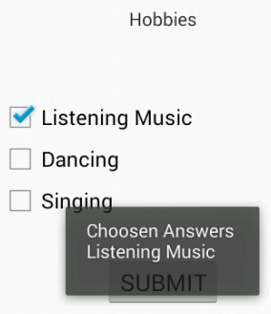

**Ex no:4**

**RANDOM COLORS USING TIMER**

**Program:**

**activity_main.xml**

<LinearLayout

xmlns:android="http://schemas.android.com/apk/res/android"

xmlns:tools="http://schemas.android.com/tools"

android:layout_width="match_parent"

android:layout_height="match_parent"

android:orientation="vertical"

tools:context=".MainActivity" >

<ImageView

android:id="@+id/image_view1"

android:layout_width="match_parent"

android:layout_height="225dp"

android:layout_weight="0.92"/>

<ImageView

android:id="@+id/image_view2"

android:layout_width="match_parent"

android:layout_height="wrap_content"

android:layout_weight="16.29"/>

</LinearLayout>

**MainActivity.xml**

package com.example.color;

import java.util.Random;

import java.util.Timer;

import java.util.TimerTask;

import android.os.Bundle;

import android.app.Activity;

import android.graphics.Color;

import android.view.Menu;

import android.widget.ImageView;

public class MainActivity extends Activity {

ImageView image_view1,image_view2;

@Override

protected void onCreate(Bundle savedInstanceState) {

super.onCreate(savedInstanceState);

setContentView(R.layout.activity_main);

image_view1=(ImageView)findViewById(R.id. image_view1);

image_view2=(ImageView)findViewById(R.id. image_view2);

Timer timer=new Timer();

MyTimer mytimer=new MyTimer();

timer.schedule(mytimer,2000,2000);

}

private class MyTimer extends TimerTask{

@Override

public void run() {

runOnUiThread(new Runnable()

{

@Override

public void run() {

Random random=new Random();

image_view1.setBackgroundColor(Color.rgb(255,random.nextInt(256),random.nextInt(256)));

image_view2.setBackgroundColor(Color.rgb(255,random.nextInt(256),random.nextInt(256)));

}

});

}

}

}

**Output:**

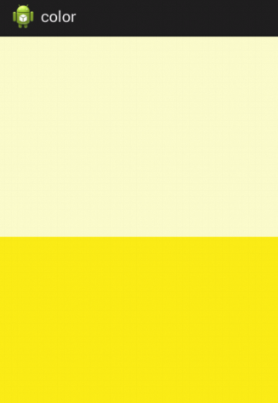

**Ex no:5**

**STYLES**

**Program:**

**activity_main.xml**

<RelativeLayout xmlns:android="http://schemas.android.com/apk/res/android"

xmlns:tools="http://schemas.android.com/tools"

android:layout_width="match_parent"

android:layout_height="match_parent"

android:paddingBottom="@dimen/activity_vertical_margin"

android:paddingLeft="@dimen/activity_horizontal_margin"

android:paddingRight="@dimen/activity_horizontal_margin"

android:paddingTop="@dimen/activity_vertical_margin"

tools:context=".MainActivity" >

<LinearLayout

android:layout_width="match_parent"

android:layout_height="match_parent">

<TableLayout

android:layout_width="match_parent"

android:layout_height="320dp" >

<TextView

android:id="@+id/TV1"

style="@style/Style1"

android:layout_width="wrap_content"

android:layout_height="wrap_content"

android:gravity="center|center_horizontal"

android:text="Congratulations on being part of team1"

android:textAlignment="center" />

<TextView

android:id="@+id/TV2"

style="@style/Style2"

android:layout_width="wrap_content"

android:layout_height="wrap_content"

android:gravity="center|center_horizontal"

android:text="The whole company welcomes you,"

android:textAlignment="center" />

<TextView

android:id="@+id/TV3"

style="@style/Style3"

android:layout_width="wrap_content"

android:layout_height="wrap_content"

android:gravity="center|center_horizontal"

android:text="We look forward to a succesful journey!"

android:textAlignment="center" />

<TextView

android:id="@+id/Tv4"

style="@style/Style4"

android:layout_width="wrap_content"

android:layout_height="wrap_content"

android:layout_weight="0.00"

android:gravity="center|center_horizontal"

android:text="Welcome aboard!"

android:textAlignment="center" />

<TableRow

android:layout_width="match_parent"

android:layout_height="match_parent"

android:layout_marginTop="50dp">

</TableRow>

<TableRow

android:layout_width="match_parent"

android:layout_height="match_parent"

android:layout_marginTop="50dp">

</TableRow>

</TableLayout>

</LinearLayout>

</RelativeLayout>

**styles.xml**

<resources xmlns:android="http://schemas.android.com/apk/res/android">

<!--

Base application theme, dependent on API level. This theme is replaced

by AppBaseTheme from res/values-vXX/styles.xml on newer devices.

-->

<style name="AppBaseTheme" parent="android:Theme.Light">

<!--

Theme customizations available in newer API levels can go in

res/values-vXX/styles.xml, while customizations related to

backward-compatibility can go here.

-->

</style>

<!-- Application theme. -->

<style name="AppTheme" parent="AppBaseTheme">

<!-- All customizations that are NOT specific to a particular API-level can go here. -->

</style>

<style name="Style1">

<item name="android:layout_height">fill_parent</item>

<item name="android:layout_width">wrap_content</item>

<item name="android:capitalize">characters</item>

<item name="android:typeface">monospace</item>

<item name="android:textSize">12pt</item>

<item name="android:textColor">#9C27B0</item>

<item name="android:textStyle">bold</item>

</style>

<style name="Style2">

<item name="android:layout_height">fill_parent</item>

<item name="android:layout_width">wrap_content</item>

<item name="android:capitalize">sentences</item>

<item name="android:typeface">sans</item>

<item name="android:textSize">16pt</item>

<item name="android:textColor">#4CAF50</item>

<item name="android:textStyle">bold</item>

</style>

<style name="Style3">

<item name="android:layout_height">fill_parent</item>

<item name="android:layout_width">wrap_content</item>

<item name="android:capitalize">sentences</item>

<item name="android:typeface">normal</item>

<item name="android:textSize">15pt</item>

<item name="android:textColor">#4BBBBB</item>

<item name="android:textStyle">bold</item>

</style>

<style name="Style4">

<item name="android:layout_height">fill_parent</item>

<item name="android:layout_width">wrap_content</item>

<item name="android:capitalize">sentences</item>

<item name="android:typeface">monospace</item>

<item name="android:textSize">10pt</item>

<item name="android:textColor">#5C27B0</item>

<item name="android:textStyle">bold</item>

</style>

</resources>

**Output:**

